How to Set Up Your Krptic Oasis Login – Android

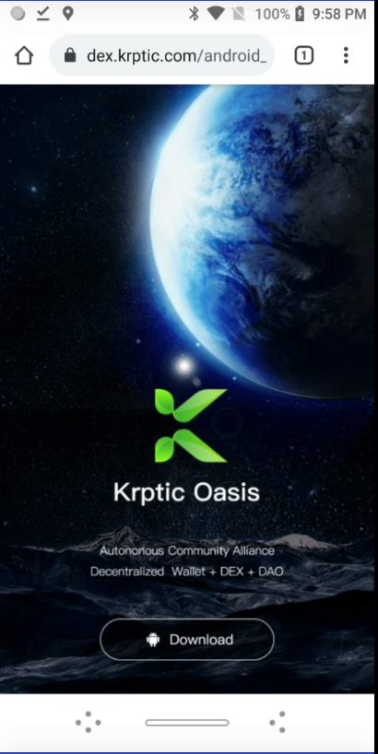

On your Android device, go to krptic.com to download Krptic Oasis

IMPORTANT!: Ensure you have passcode (screen lock) enabled on your device before installing the Krptic app. If it is not enabled, you will not be able to proceed with your Krptic download.

After you have downloaded Krptic Oasis you will see the following informational screens. After reading each screen, select “Next.”

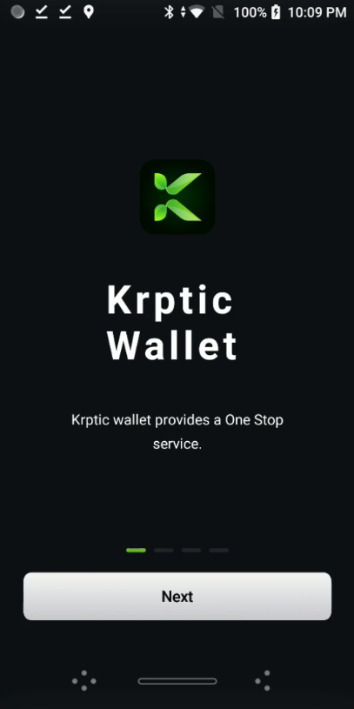

Krptic Wallet

Krptic wallet provides a One Stop service

Next

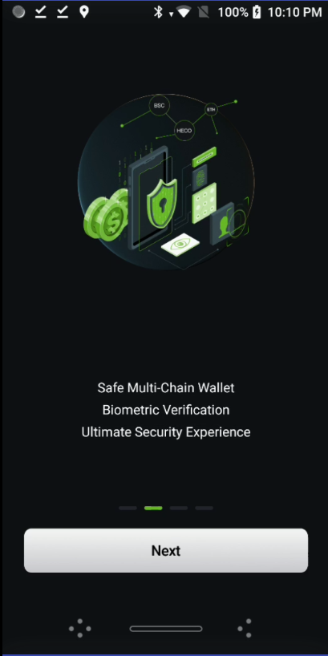

Safe Multi-Chain Wallet
Biometric Verification
Ultimate Security Experience

Next

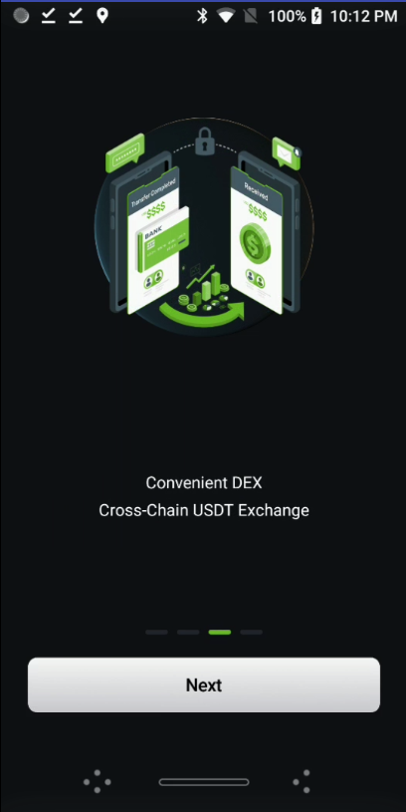

Convenient DEX
Cross-Chain USDT Exchange

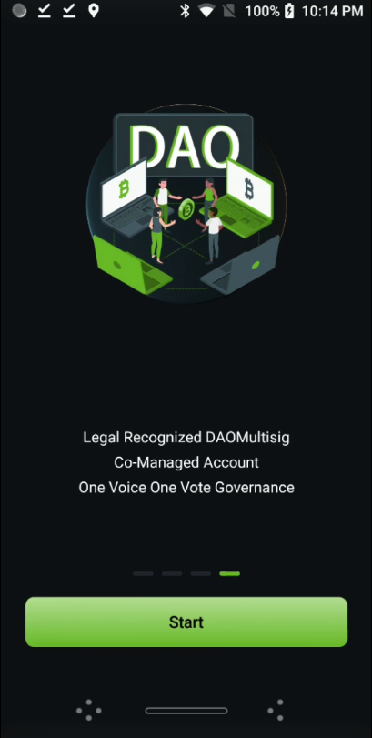

Legal Recognized DAO Multisig
Co-Managed Account
One Voice One Vote Governance

Start (touch Start)

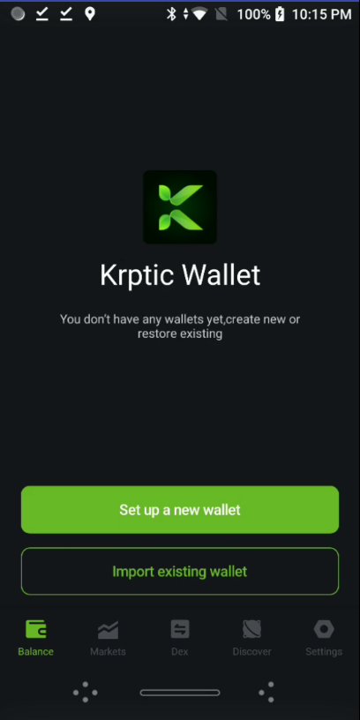

Krptic Wallet
You don’t have any wallets yet. Create new or restore existing

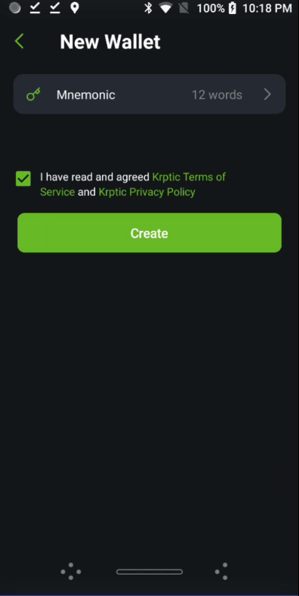

New Wallet

Mnemonic – 12 words (12 words is default; you can change this to 24)

⊠ I have read and agreed Krptic Terms of Service and Krptic Privacy Policy

Create (touch Create)

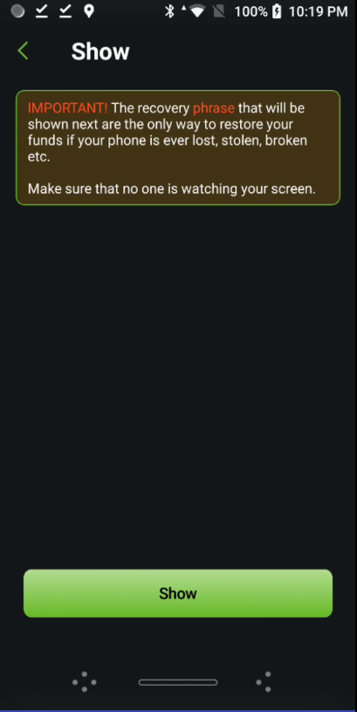

Show

IMPORTANT! The recovery phrase that will be shown next are the only way to restore your funds if your phone is ever lost, stolen, broken, etc.

Make sure that no one is watching your screen.

Show

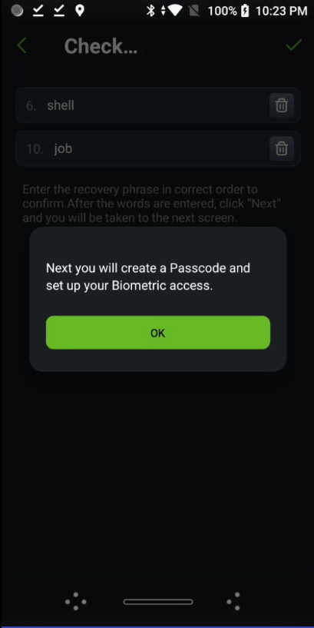

Before you see this screen, you will be shown your secret mnemonic words – either 12 or 24.
The screen above (Check…) will ask you to provide specific words from the previous screen. In this instance, it is asking for words number 6 and 10 from your list. Type in those words.
Next you will create a Passcode and set up your Biometric access.
Touch OK to go to the next screen.
On the next three screens, you will be asked to allow Krptic to access your photos, media, files, camera and microphone. If you wish to proceed, touch allow on each screen.
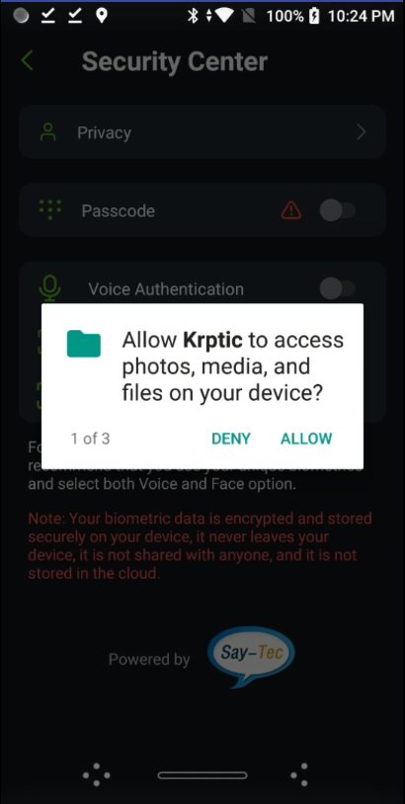

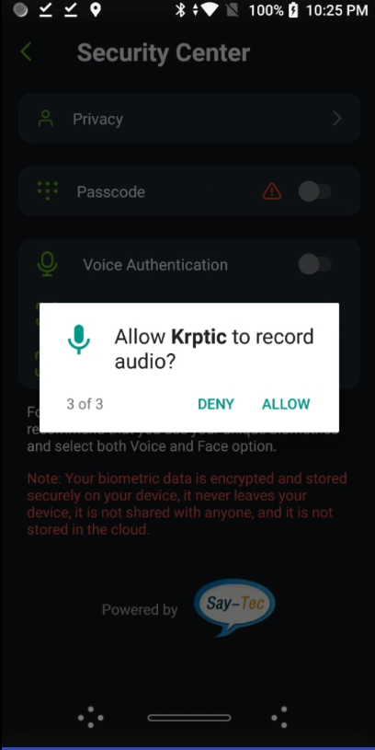
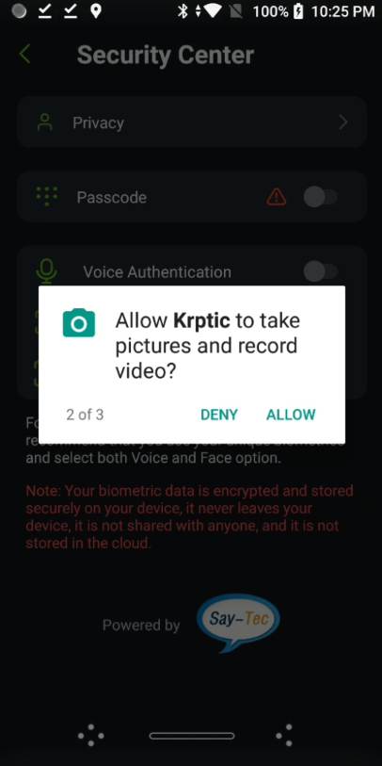

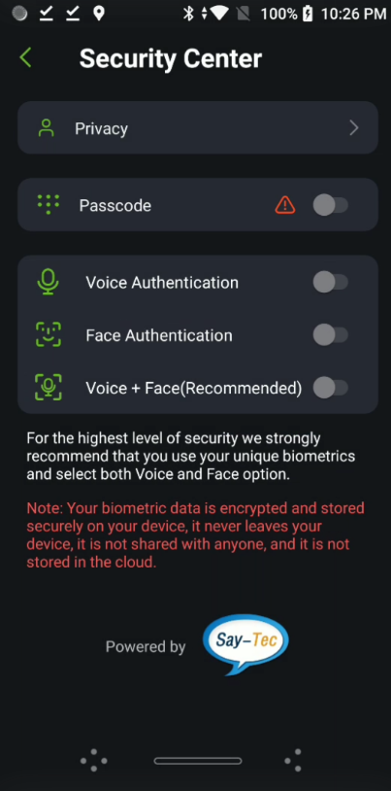

Security Center

Privacy

Passcode

Voice Authentication

Face Authentication

Voice + Face (Recommended)

For the highest level of security we strongly recommend that you use your unique biometrics and select both Voice and Face option.

Note: Your biometric data is encrypted and stored securely on your device. It never leaves your device, it is not shared with anyone, and it is not stored in the cloud.

Powered by Say-Tec

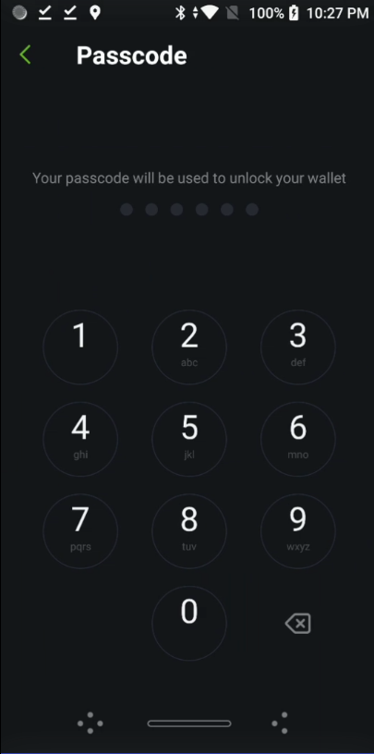

Passcode

You will be asked to create a passcode using 6 numbers. Make sure you use numbers you will remember.

After entering your 6 numbers, you will be asked to enter them again to confirm.

After confirming your 6-digit Passcode, you will be returned to the Security Center screen and a pop-up screen will appear:

Please select your choice for Biometric authentication – Voice and Face is recommended.

Get

After pressing Get, you will be returned to the Security Center screen.

You now have the option to select Voice Authentication, Face Authentication, or Voice + Face (which is recommended).

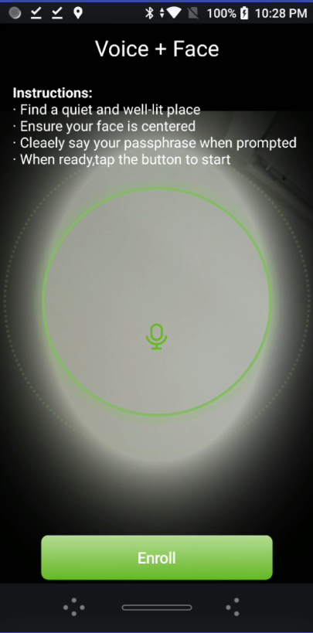

Now you are at the screen where you will see your face in a circle.

Press enroll then say your “unlock phrase” two or three times. (Your unlock phrase should be two to four words).

Your face and voice information will be captured, and you will be taken back to the Security Center.

To test your setup, exit out of Krptic then go back in. If you chose Face + Voice, you will look into your phone as you did when setting up your biometrics and say your chosen unlock phrase.

You are now able to access the features of Krptic Oasis..

